Explainable AI

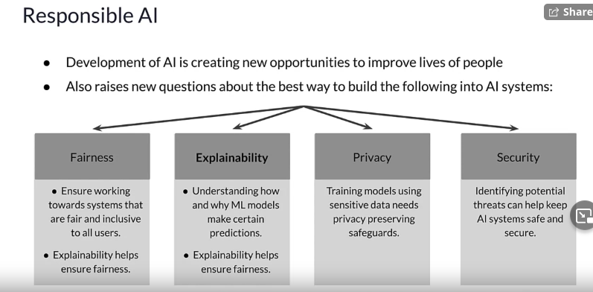
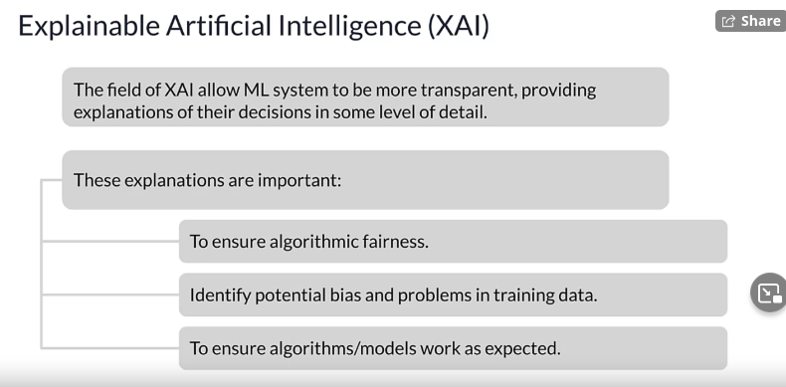
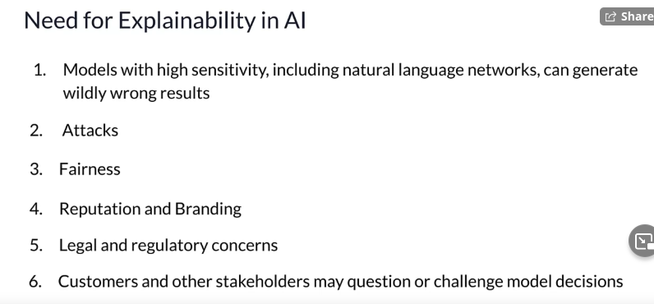
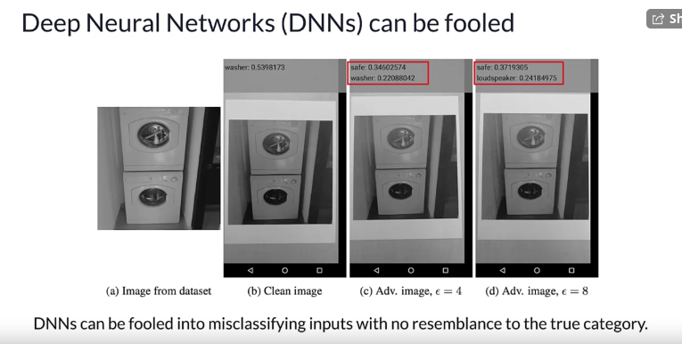
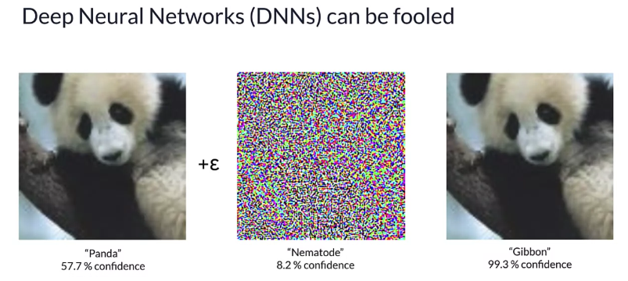

Model Interpretation Methods

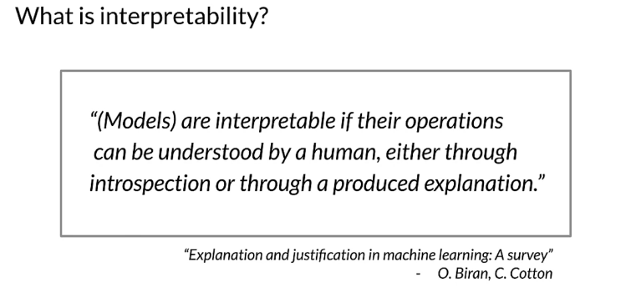
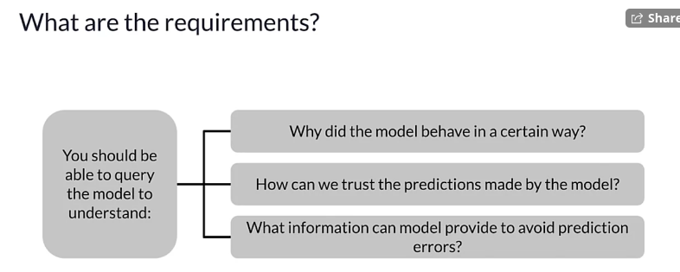
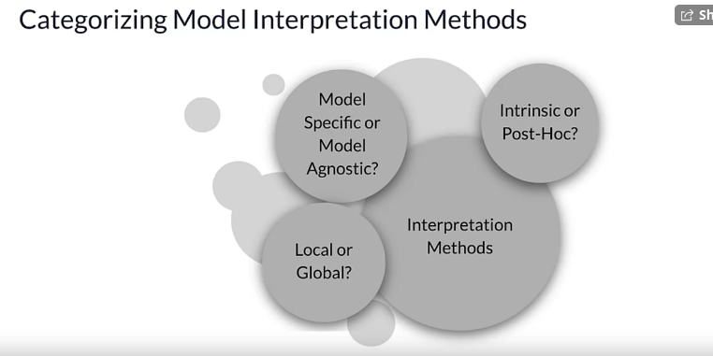
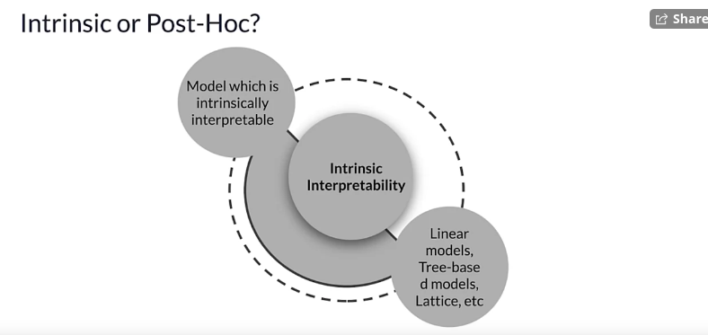
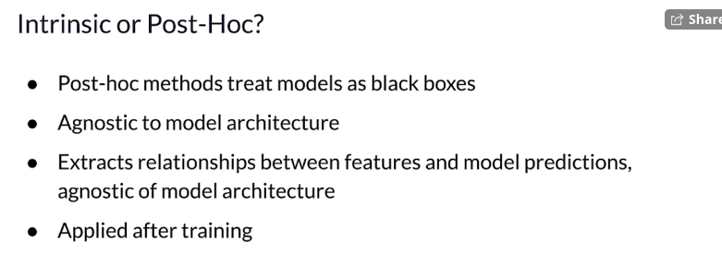
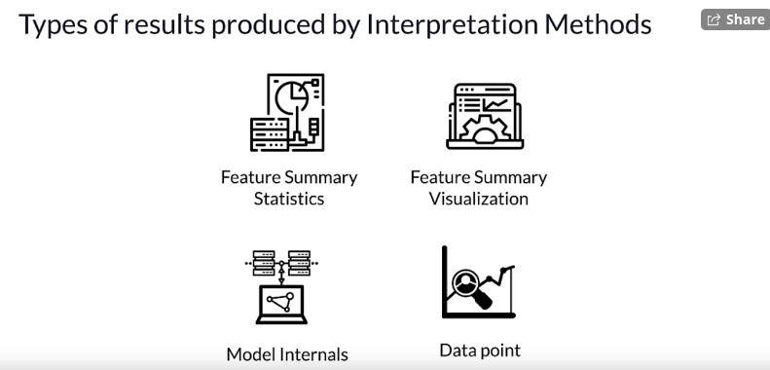

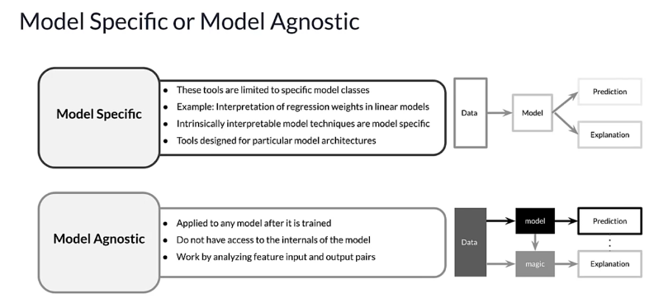
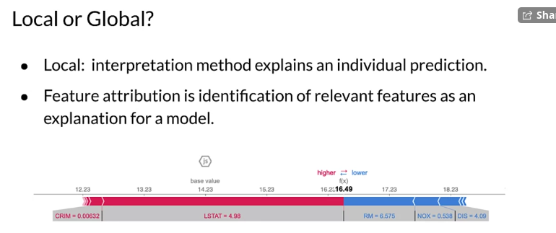
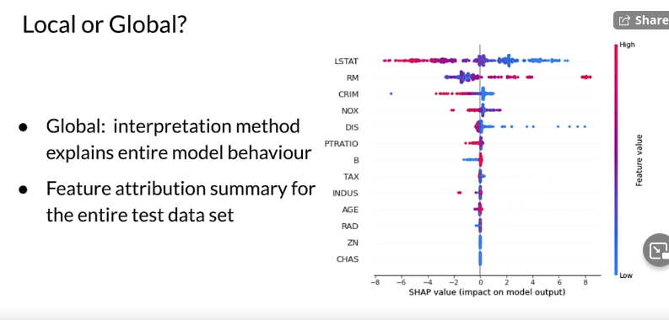

Intrinsically Interpretable Models

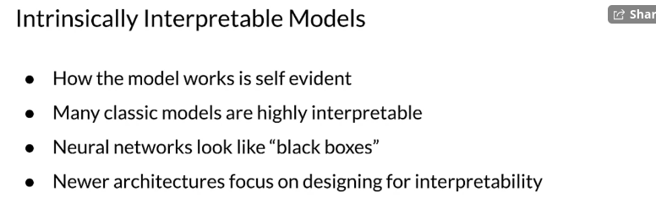
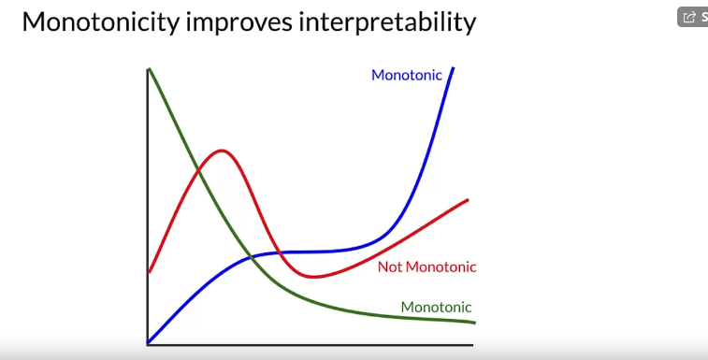
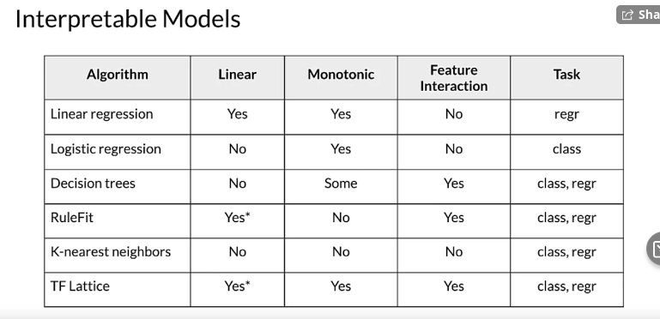

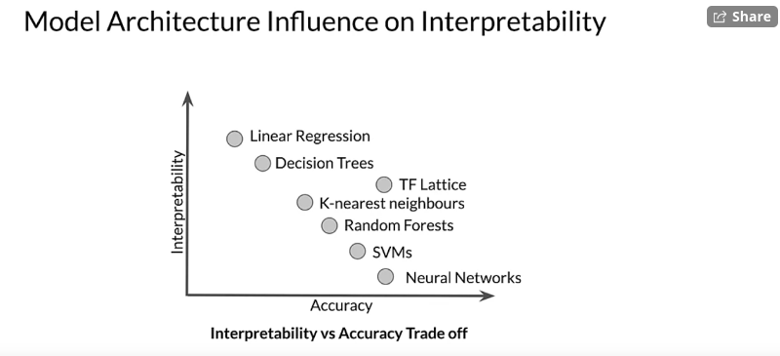
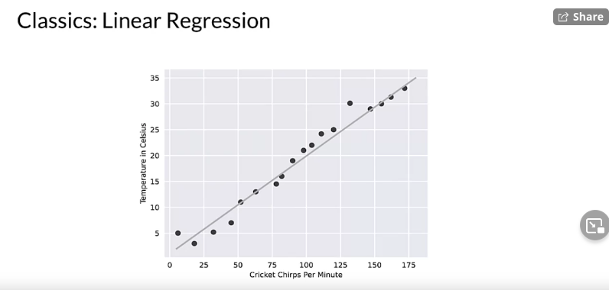
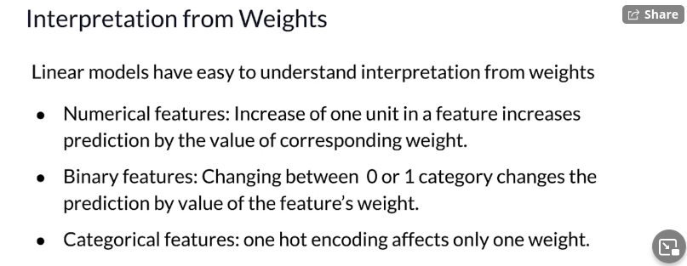
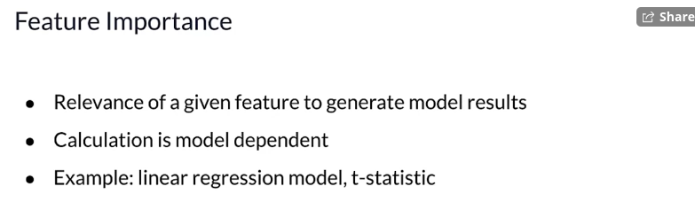
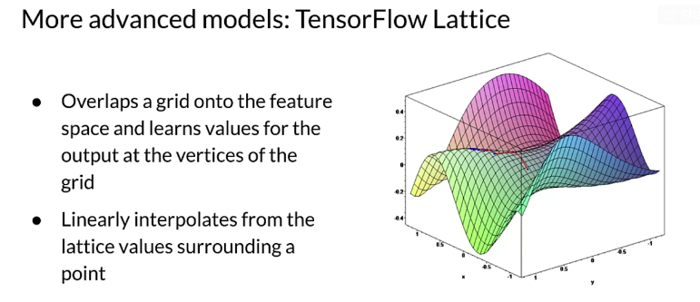
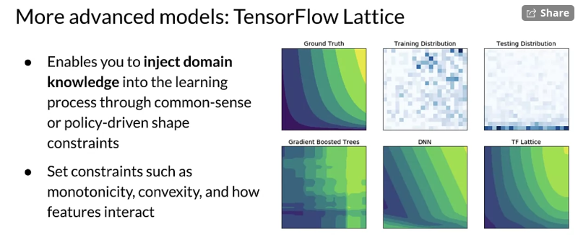
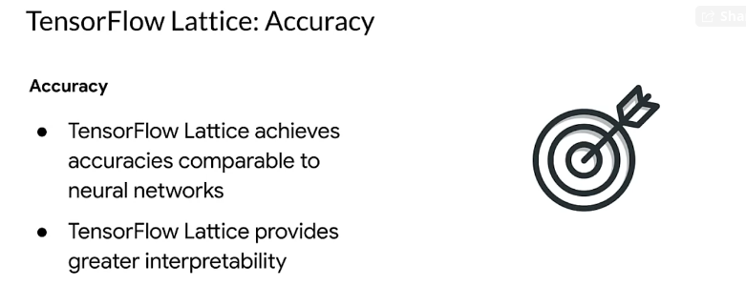
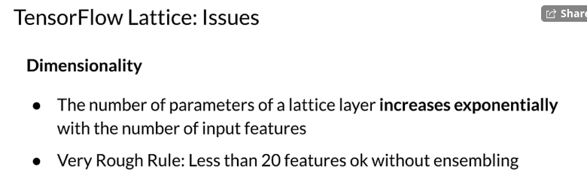

Model Agnostic Methods

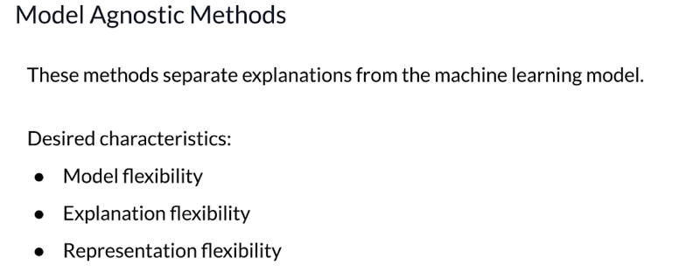
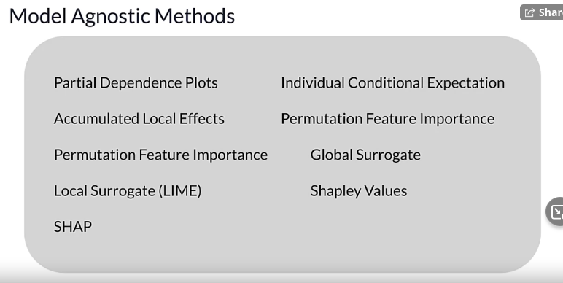

Partial Dependence Plots

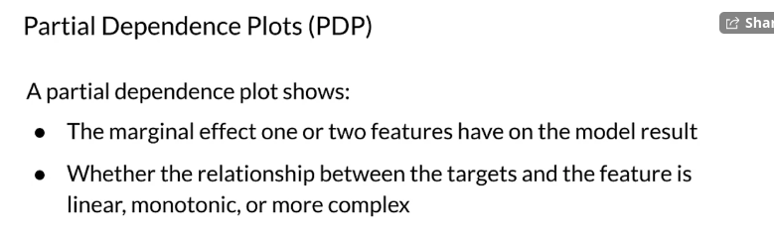
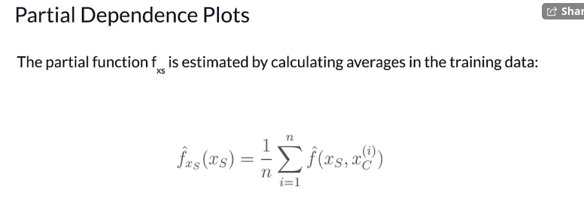
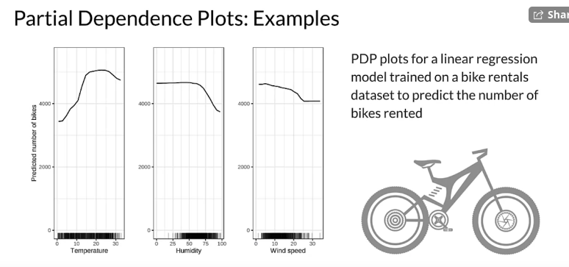
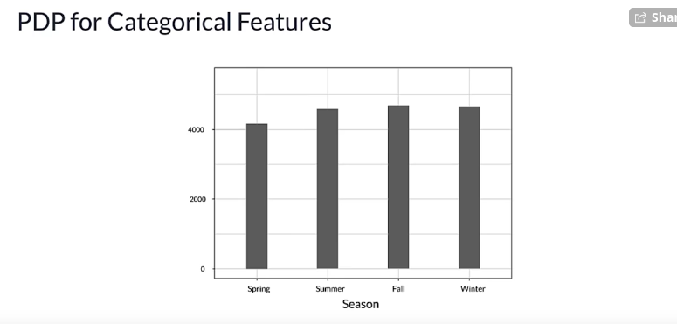
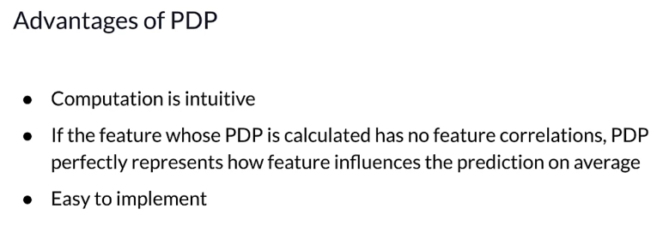
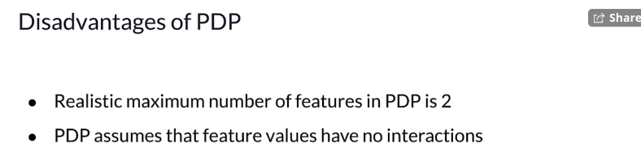

Permutation Feature Importance

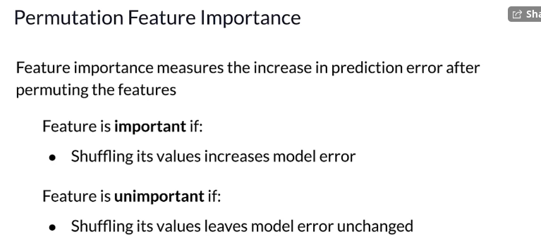
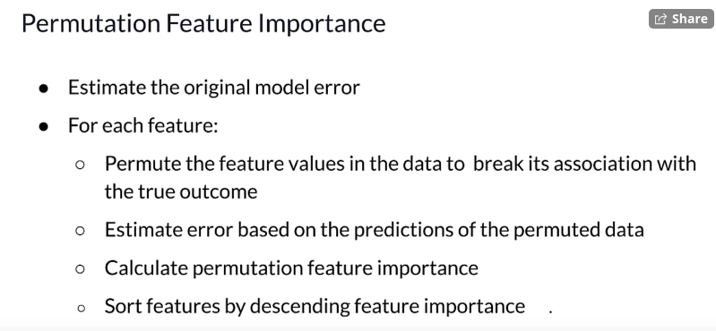
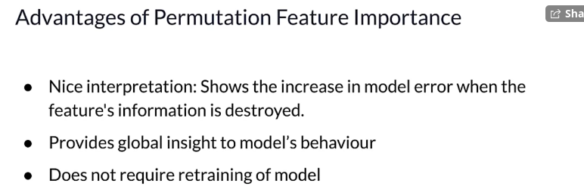
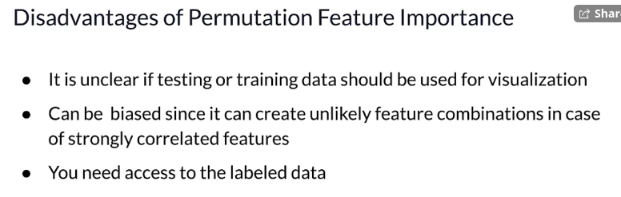

Shapley Values

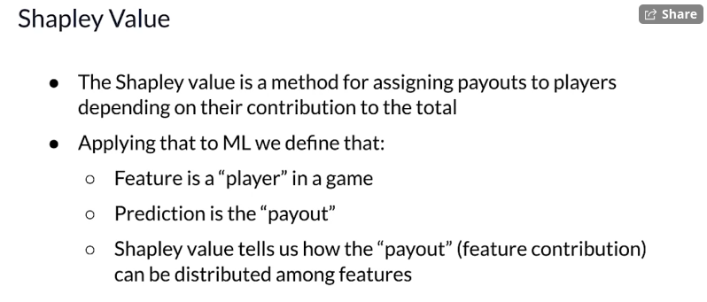
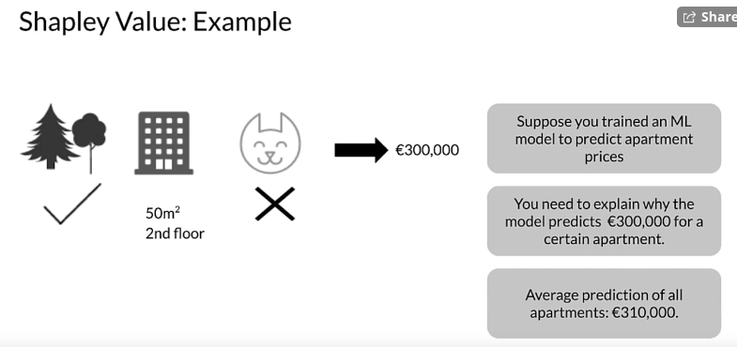
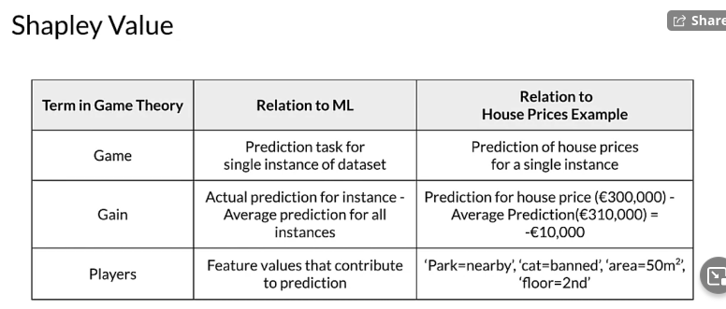
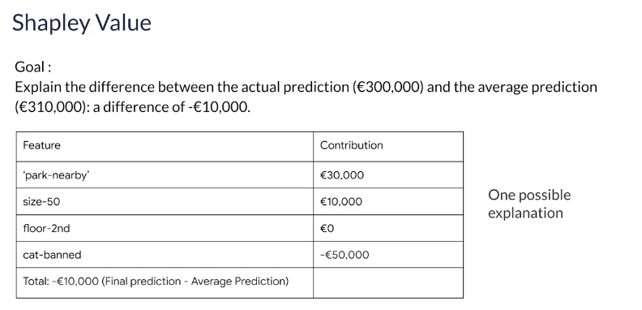
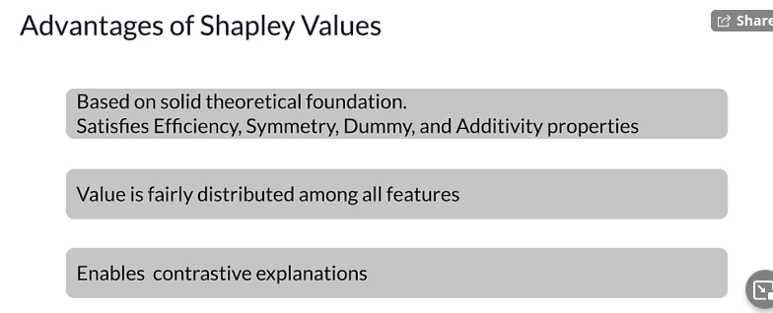
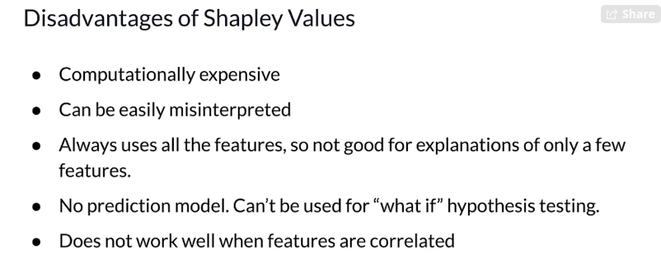

SHapley Additive exPlanations (SHAP)

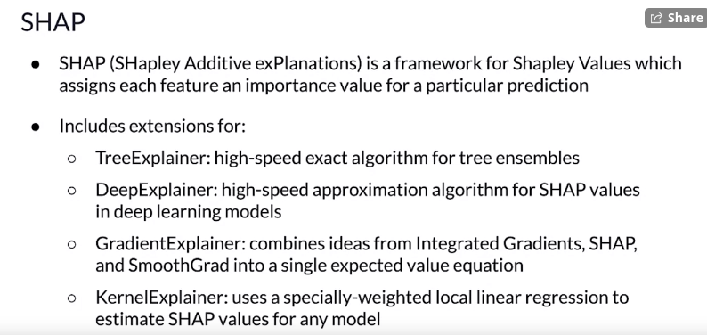
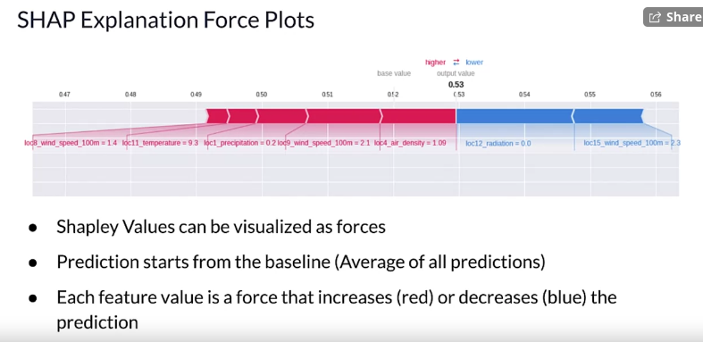
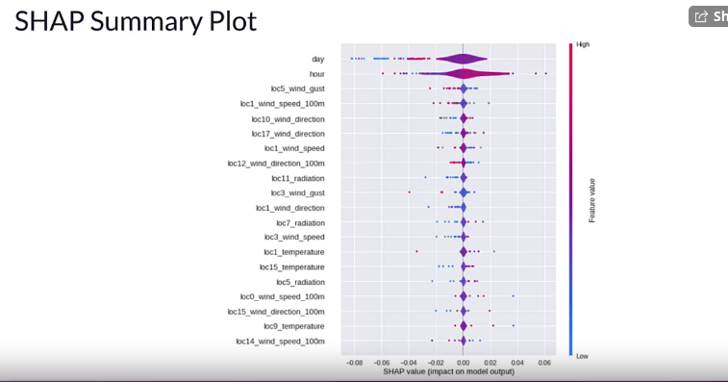
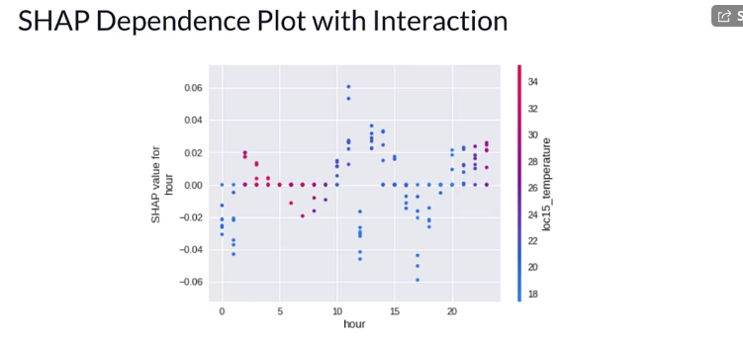

Testing Concept Activation Vectors

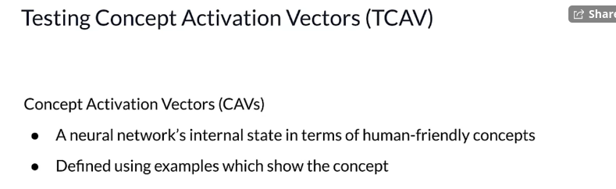
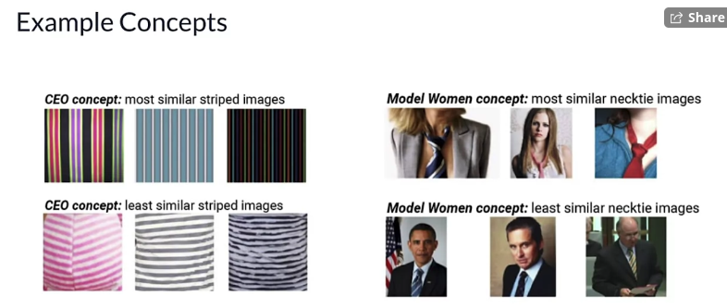

LIME

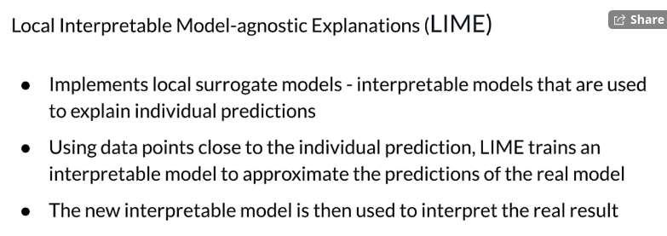

AI Explanations

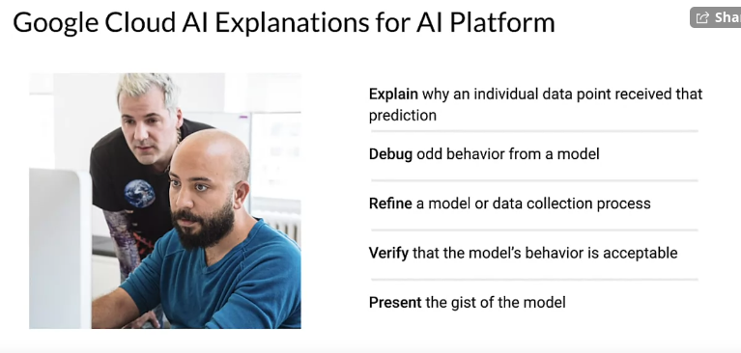
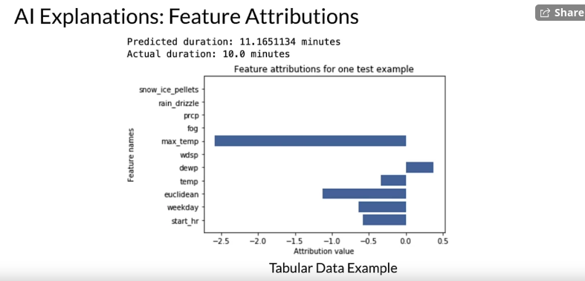

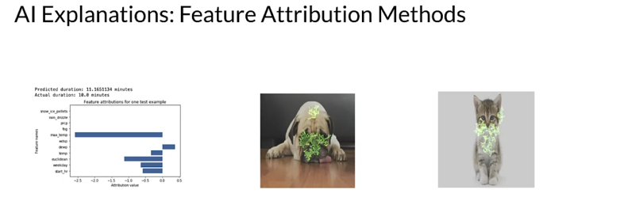
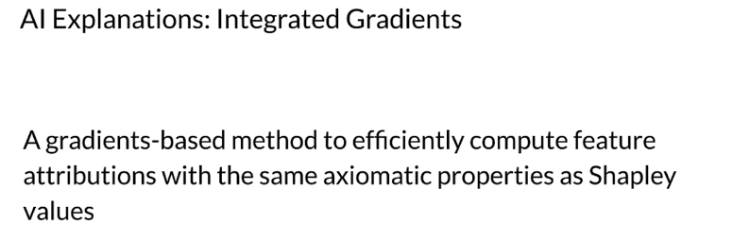
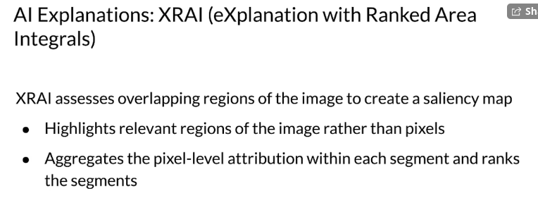
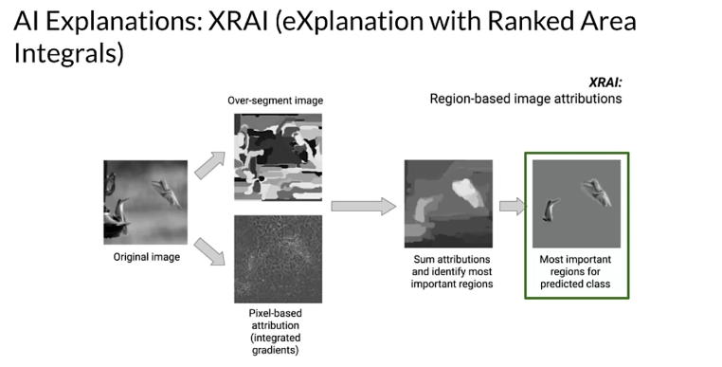

Machine Learning Modeling Pipelines in Production
This is a compilation of resources including URLs and papers appearing in lecture videos. If you wish to dive more deeply into the topics covered this week, feel free to check out these optional references.

Overall resources:
Towards ML Engineering - History of TFX:
https://arxiv.org/abs/2010.02013
Challenges in Deploying ML:
https://arxiv.org/abs/2011.09926

Week 1: Neural Architecture Search
Neural Architecture Search:
https://arxiv.org/pdf/1808.05377.pdf
Bayesian Optimization:
https://distill.pub/2020/bayesian-optimization/
Neural Architecture Search with Reinforcement Learning:
https://arxiv.org/pdf/1611.01578.pdf
Progressive Neural Architecture Search:
https://arxiv.org/pdf/1712.00559.pdf
Network Morphism:
https://arxiv.org/abs/1603.01670
Amazon SageMaker Autopilot
https://aws.amazon.com/sagemaker/autopilot
Microsoft Azure Automated Machine Learning
https://azure.microsoft.com/en-in/services/machine-learning/automatedml/
Google Cloud AutoML
https://cloud.google.com/automl

Week 2: Model Resource Management Techniques
High dimensional spaces visualization:
https://colab.research.google.com/drive/1GTBYAcMsiKDDQeDpyOIi_DGuPVleJAf0?usp=sharing
Word embeddings:
https://heartbeat.fritz.ai/coreml-with-glove-word-embedding-and-recursive-neural-network-part-2-d72c1a66b028
Curse of dimensionality:
https://builtin.com/data-science/curse-dimensionality
https://www.visiondummy.com/2014/04/curse-dimensionality-affect-classification/
Sparsity:
https://www.kdd.org/exploration_files/parsons.pdf
Feature engineering:
https://quantdare.com/what-is-the-difference-between-feature-extraction-and-feature-selection/
https://machinelearningmastery.com/discover-feature-engineering-how-to-engineer-features-and-how-to-get-good-at-it/
PCA:
https://scikit-learn.org/stable/modules/decomposition.html
https://www.coursera.org/lecture/machine-learning/principal-component-analysis-problem-formulation-GBFTt
https://stats.stackexchange.com/questions/2691/making-sense-of-principal-component-analysis-eigenvectors-eigenvalues/140579#140579
https://elitedatascience.com/dimensionality-reduction-algorithms
ICA:
https://scikit-learn.org/stable/modules/decomposition.html
https://scikit-learn.org/stable/auto_examples/decomposition/plot_ica_vs_pca.html
NMF:
https://scikit-learn.org/stable/modules/decomposition.html#non-negative-matrix-factorization-nmf-or-nnmf
Mobile model deployment:
https://developers.google.com/ml-kit
https://www.tensorflow.org/lite
Quantization:
https://www.qualcomm.com/news/onq/2019/03/12/heres-why-quantization-matters-ai
https://petewarden.com/2016/05/03/how-to-quantize-neural-networks-with-tensorflow/
https://arxiv.org/abs/1712.05877
https://blog.tensorflow.org/2020/04/quantization-aware-training-with-tensorflow-model-optimization-toolkit.html
https://www.tensorflow.org/lite/performance/best_practices
Post-training quantization:
https://medium.com/tensorflow/introducing-the-model-optimization-toolkit-for-tensorflow-254aca1ba0a3
Quantization aware training:
https://blog.tensorflow.org/2020/04/quantization-aware-training-with-tensorflow-model-optimization-toolkit.html
Pruning:
https://blog.tensorflow.org/2019/05/tf-model-optimization-toolkit-pruning-API.html
http://yann.lecun.com/exdb/publis/pdf/lecun-90b.pdf
https://towardsdatascience.com/can-you-remove-99-of-a-neural-network-without-losing-accuracy-915b1fab873b
https://arxiv.org/abs/1803.03635
https://numenta.com/blog/2019/08/30/case-for-sparsity-in-neural-networks-part-1-pruning
https://www.tensorflow.org/model_optimization/guide/pruning

Week 3: High Performance Modeling
Distribution strategies:
https://www.tensorflow.org/guide/distributed_training
Changes in data parallelism:
https://arxiv.org/abs/1806.03377
Pipeline parallelism:
https://ai.googleblog.com/2019/03/introducing-gpipe-open-source-library.html
GPipe:
https://github.com/tensorflow/lingvo/blob/master/lingvo/core/gpipe.py
https://arxiv.org/abs/1811.06965
GoogleNet:
https://arxiv.org/abs/1409.4842
Knowledge distillation:
https://ai.googleblog.com/2018/05/custom-on-device-ml-models.html
https://arxiv.org/pdf/1503.02531.pdf
https://nervanasystems.github.io/distiller/knowledge_distillation.html
DistilBERT:
https://blog.tensorflow.org/2020/05/how-hugging-face-achieved-2x-performance-boost-question-answering.html
Two-stage multi-teacher distillation for Q & A:
https://arxiv.org/abs/1910.08381
EfficientNets:
https://arxiv.org/abs/1911.04252

Week 4: Model Performance Analysis
TensorBoard:
https://blog.tensorflow.org/2019/12/introducing-tensorboarddev-new-way-to.html
Model Introspection:
https://www.kaggle.com/c/dogs-vs-cats/data
Optimization process:
https://cs231n.github.io/neural-networks-3/
TFMA architecture:
https://www.tensorflow.org/tfx/model_analysis/architecture
TFMA:
https://blog.tensorflow.org/2018/03/introducing-tensorflow-model-analysis.html
Aggregate versus slice metrics:
https://blog.tensorflow.org/2018/03/introducing-tensorflow-model-analysis.html
What-if tool:
https://pair-code.github.io/what-if-tool/
https://www.google.com/url?q=https://www.youtube.com/playlist?list%3DPLIivdWyY5sqK7Z5A2-sftWLlbVSXuyclr&sa=D&source=editors&ust=1620676474220000&usg=AFQjCNEF_ONMs8YkdUtgUp2-stfKmDdWtA
Partial Dependence Plots:
https://github.com/SauceCat/PDPbox
https://github.com/AustinRochford/PyCEbox
Adversarial attacks:
http://karpathy.github.io/2015/03/30/breaking-convnets/
https://arxiv.org/pdf/1707.08945.pdf
Informational and behavioral harms:
https://fpf.org/wp-content/uploads/2019/09/FPF_WarningSigns_Report.pdf
Clever Hans:
https://github.com/cleverhans-lab/cleverhans
Foolbox:
https://foolbox.jonasrauber.de/
Defensive distillation:
https://arxiv.org/abs/1511.04508
Concept Drift detection for Unsupervised Learning:
https://arxiv.org/pdf/1704.00023.pdf
Cloud providers:
https://cloud.google.com/ai-platform/prediction/docs/continuous-evaluation
https://aws.amazon.com/sagemaker/model-monitor
https://docs.microsoft.com/en-us/azure/machine-learning/how-to-monitor-datasets
Fairness:
https://www.tensorflow.org/responsible_ai/fairness_indicators/guide
Fairness Indicators:
https://www.tensorflow.org/responsible_ai/fairness_indicators/guide
Model Remediation:
https://www.tensorflow.org/responsible_ai/model_remediation
AIF360:
http://aif360.mybluemix.net/
Themis ML:
https://github.com/cosmicBboy/themis-ml
LFR:
https://arxiv.org/pdf/1904.13341.pdf

Week 5: Explainability
Fooling DNNs:
https://arxiv.org/pdf/1607.02533.pdf
https://arxiv.org/pdf/1412.6572.pdf
XAI:
http://www.cs.columbia.edu/~orb/papers/xai_survey_paper_2017.pdf
Interpretable models
https://christophm.github.io/interpretable-ml-book/
https://www.tensorflow.org/lattice
Dol bear law:
https://en.wikipedia.org/wiki/Dolbear%27s_law
TensorFlow Lattice:
https://www.tensorflow.org/lattice
https://jmlr.org/papers/volume17/15-243/15-243.pdf
PDP:
https://github.com/SauceCat/PDPbox
https://scikit-learn.org/stable/auto_examples/inspection/plot_partial_dependence.html
Permutation Feature Importance:
http://arxiv.org/abs/1801.01489
Shapley values:
https://en.wikipedia.org/wiki/Shapley_value
SHAP:
https://github.com/slundberg/shap
TCAV:
https://arxiv.org/pdf/1711.11279.pdf
LIME:
https://github.com/marcotcr/lime
Google Cloud XAI
https://storage.googleapis.com/cloud-ai-whitepapers/AI%20Explainability%20Whitepaper.pdf
Integrated gradients:
https://arxiv.org/pdf/1703.01365.pdf

